- Login to Powerschool
- Students
  - Set Enroll_Status = 0, click Search button beneath Search Students list
  - You should see the "Current Records in selection change to a lower number.
  - Click "Export Records" link.
  - Grab these columns
Student_Number
First_Name
Last_Name
Gender
Grade_Level
SchoolID
ID
DOB
Ethnicity
Hispanic
Migrant
homeless
  - Use Comma for field delimiter
  - Set record delimiter to CRLF
  - Use “” around fields
  - Click Submit
  - Name file <something>.csv
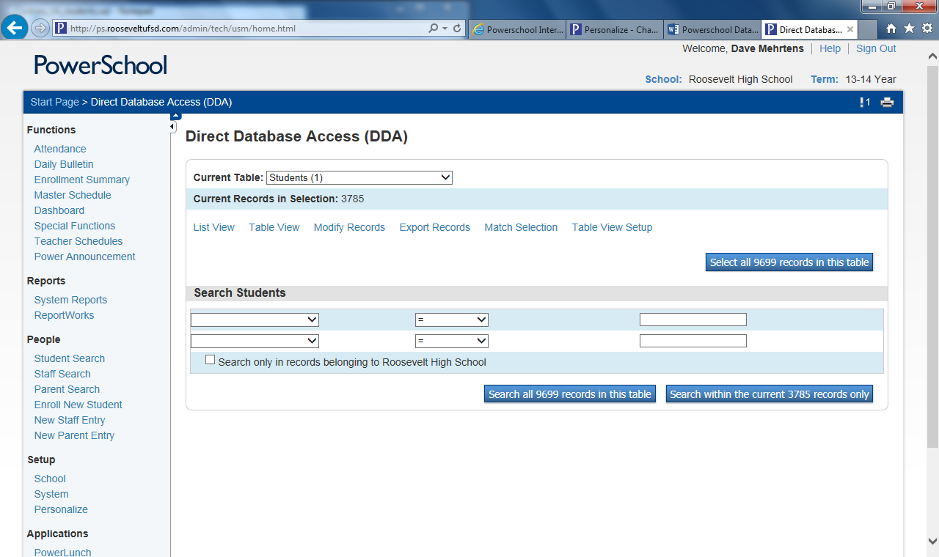
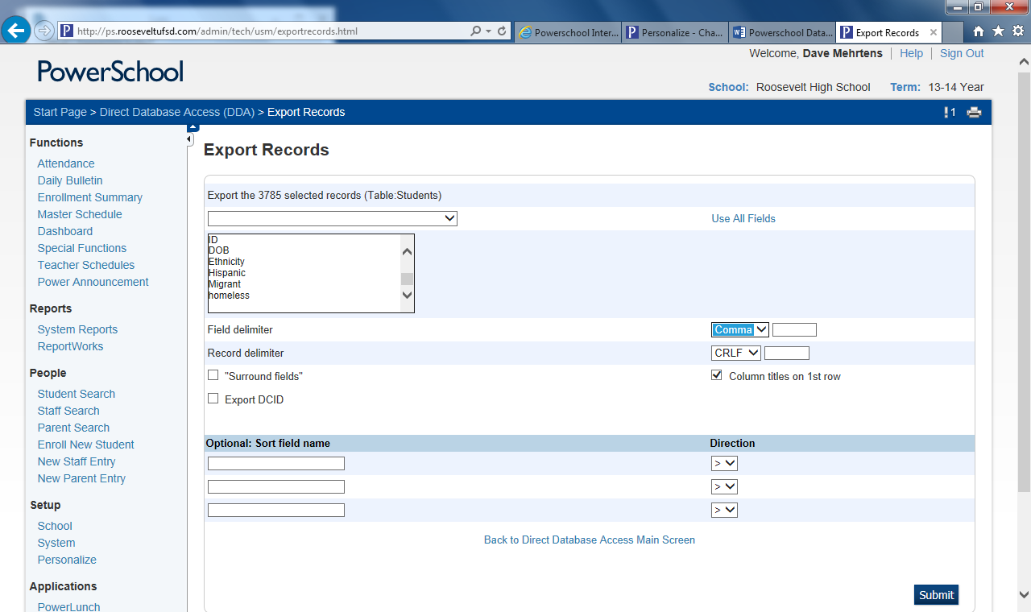
- Staff
  - Filter by Status = 1 and StaffStatus = 1
  - Click Search
  - Click Export
  - Select these fields
    - ID
    - First_Name
    - Last_Name
    - TeacherLoginID
    - NY_StaffID
  - Set options the same as above
- Courses
  - Select Courses
  - Click Select All records
- Sections
  - Select Sections
  - Filter by TermID >= 2200
  - Click Search
  - Click Export
  - grab these columns
    - ID
    - SchoolID
    - Course_Number
    - Expression
    - Teacher
    - Section_Number
  - Set options
  - export
- Roster
  - Select CC
  - Filter by termid >= 2200
  - Click Search
  - Click Export
  - Grab these
    - SectionID
    - StudentID

