2014 HEDI Sheets Using the HEDI Sheet Search Quick Guide

- Navigate to the HEDI Sheet Search page by clicking on APPR>HEDI Sheets>HEDI Sheet Search.
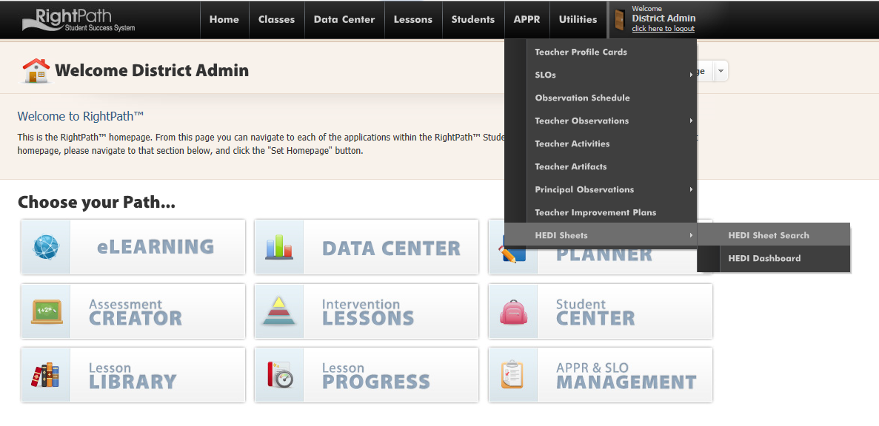

- You will be directed to the HEDI Sheet Search page. If the search box is left blank and the ‘Not Started’ radio button is selected, you will see a list of all the teachers who do not have a HEDI Sheet created yet.

You may also enter the name of a specific teacher you are looking for in the search box and select the proper radio button to see their HEDI Sheet.

- Click on the green circle with the plus sign to create a HEDI sheet.
You can click on the red circle with the white minus sign to exclude a teacher from having a HEDI Sheet.

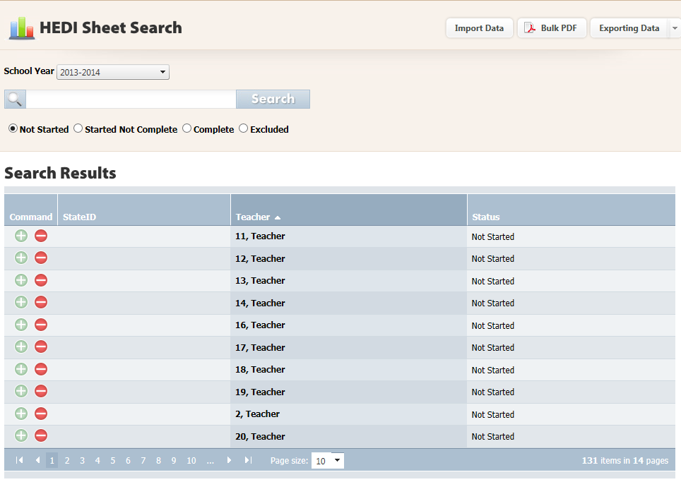
- Once you click on the plus sign, you will land on the HEDI Sheet page and a message will display to let you know the HEDI sheet was created.

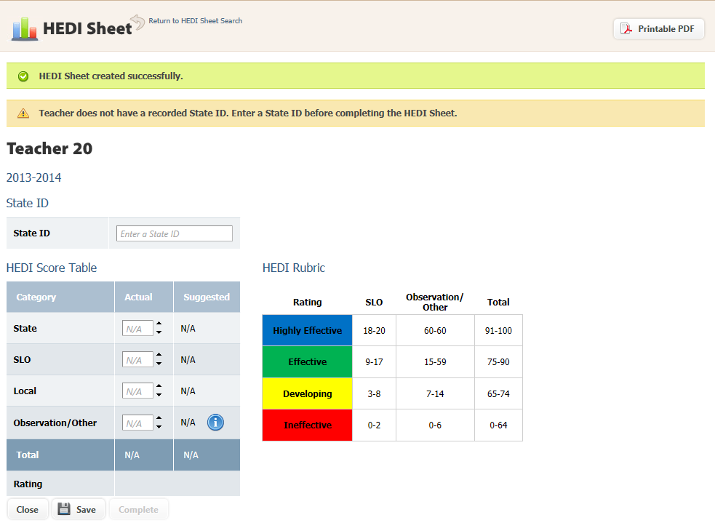

- Enter the scores and click the ‘Save’ button. You can now view the HEDI Rating. Click on the ‘Complete’ button to mark the HEDI complete.

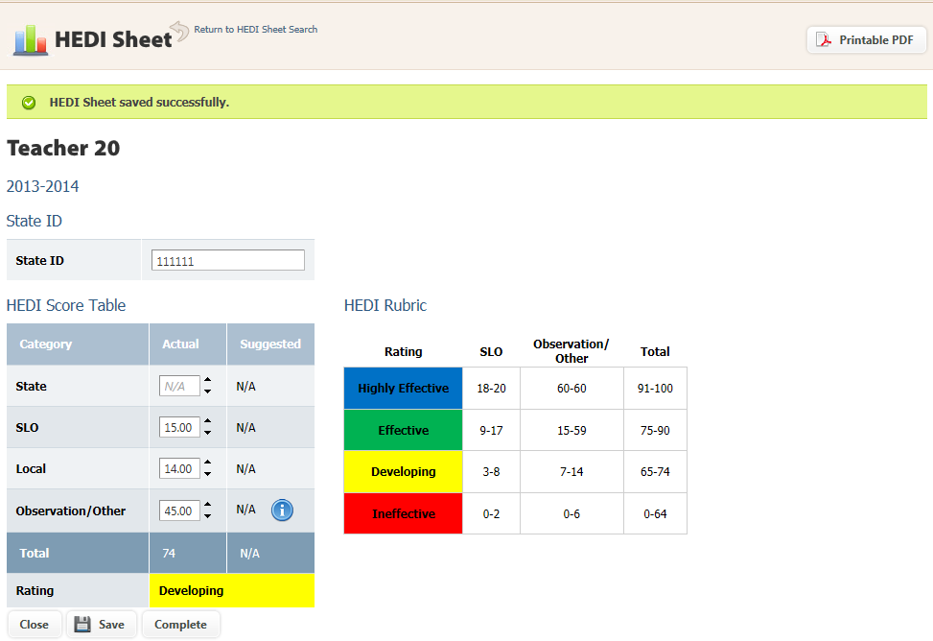

- Confirm that you want to complete this HEDI Sheet by clicking the ‘OK’ button.

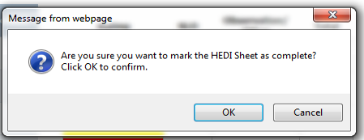

- Once the HEDI Sheet has been saved and completed, a message will display to alert you that this HEDI Sheet has been saved and completed successfully.

- Click the ‘Close’ button to leave the page and you will be returned to the HEDI Sheet Search.

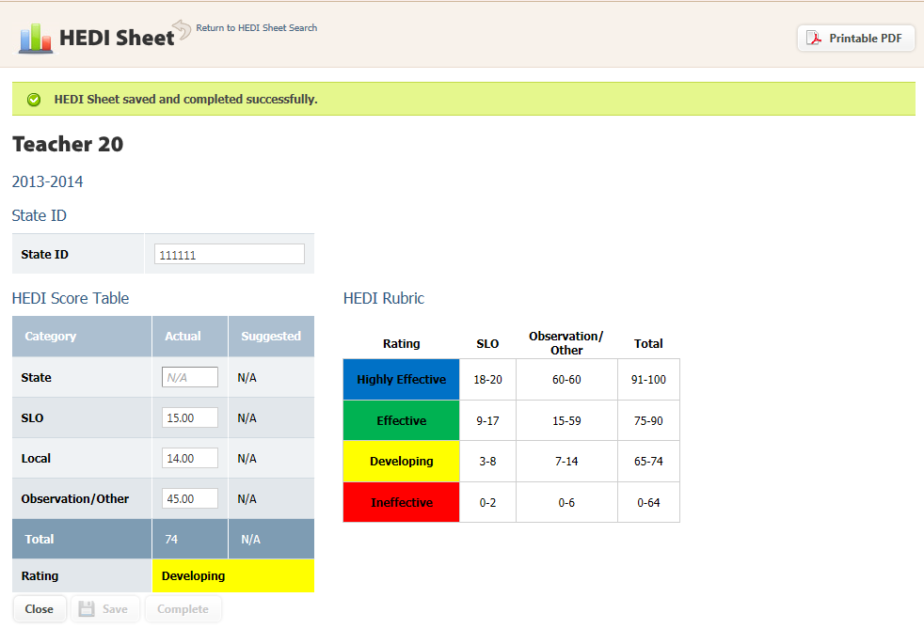

- If you need to edit a HEDI Sheet, just click on the pencil icon and you will be directed to the HEDI Sheet page to enter scores.

