SLO Required User Management User Guide

The SLO Required User Management User Guide will explain how to assign and unassign a reviewer to a teacher requiring an SLO.
A teacher can only have one SLO reviewer assigned to their account at a time. This page offers the options needed for reviewers to manage the teachers that require an SLO.
As a reviewer, you can manage your teachers by navigating to the “Required User Management” page. You can access this page by clicking on the black menu bar at the top of the screen and selecting APPR>SLOs>Required User Management.

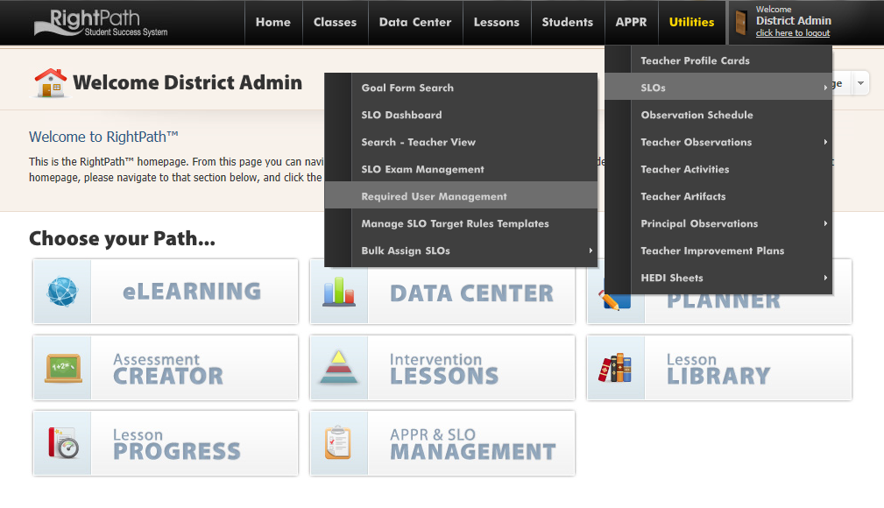

Search for your name on the Reviewers List
- Select the school year, type your name in the search box and click the reviewer radio button. Now, click on the search button.
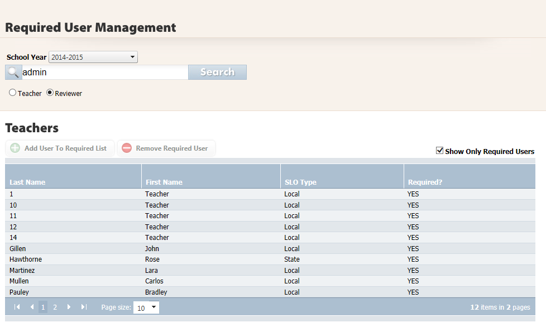
- Click on your name in the reviewer list and when the page refreshes, you will see the list of teachers that are assigned to you to review. If no teachers are assigned to you, the list will be blank.
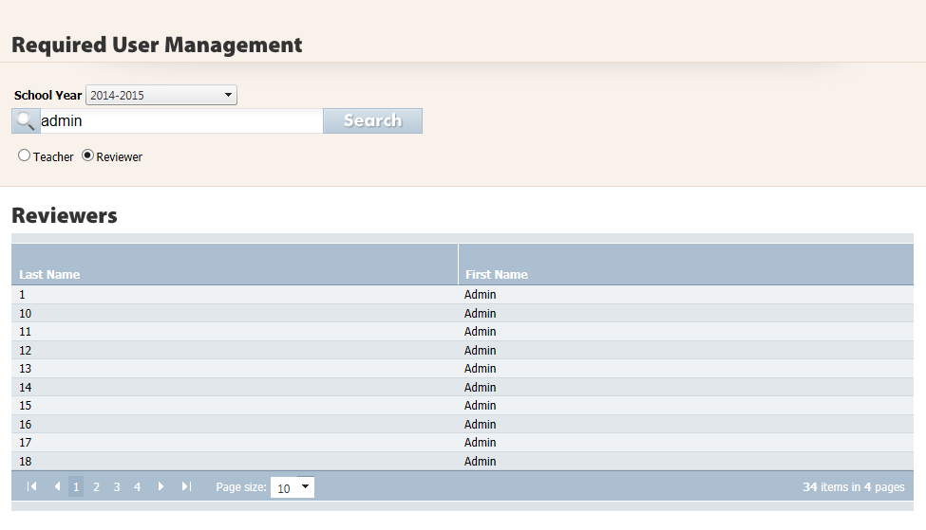

Add a teacher to your Reviewee List
- Click the tab with the green circle next to the words “Add Teacher”.
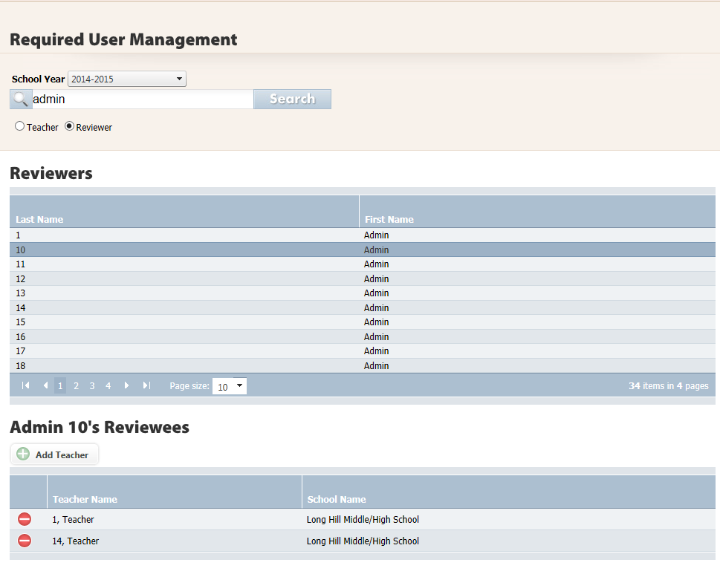
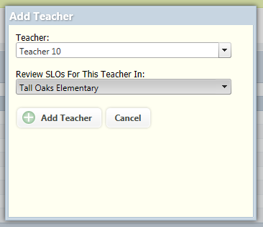
- A popup will display. Select the teacher’s name from the drop down.
- Select the teacher’s building and click the “Add Teacher” button.

When the screen refreshes, the new teacher will be added to your list of reviewees. A green alert bar will let you know the teacher was added successfully to your list. The reviewer will now have access to the teacher’s SLOs.
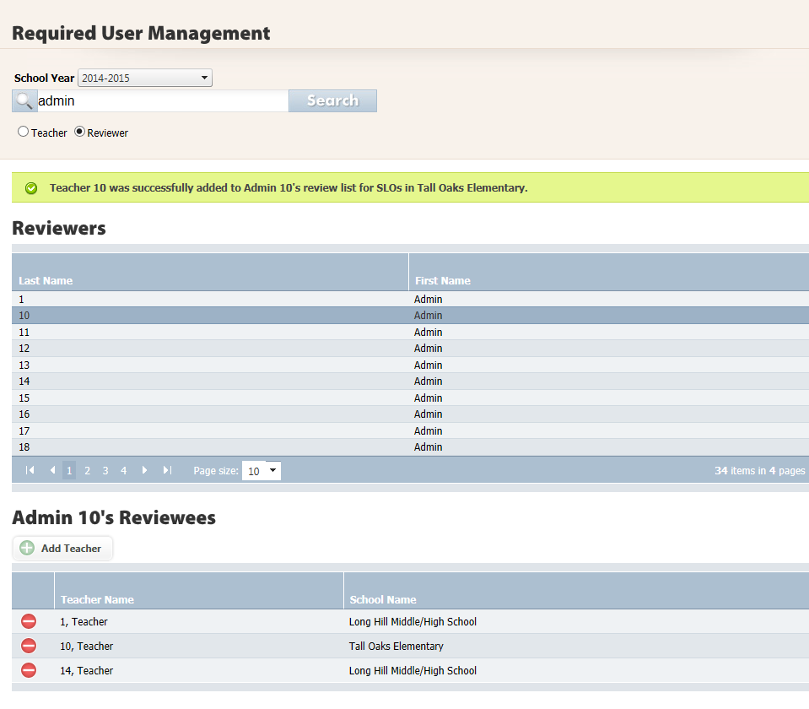

Remove a teacher from your Reviewee List
- To remove a teacher from your reviewee list, click the red circle in front of the teacher’s name you want to remove and a pop up will ask you to confirm this action.
- Click on the “ok” button and the teacher will be removed from your reviewer list. You will see a green alert to let you know this teacher was successfully removed from your reviewer list.

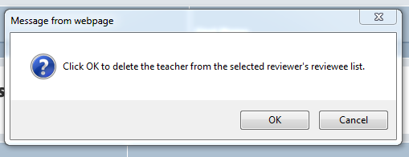
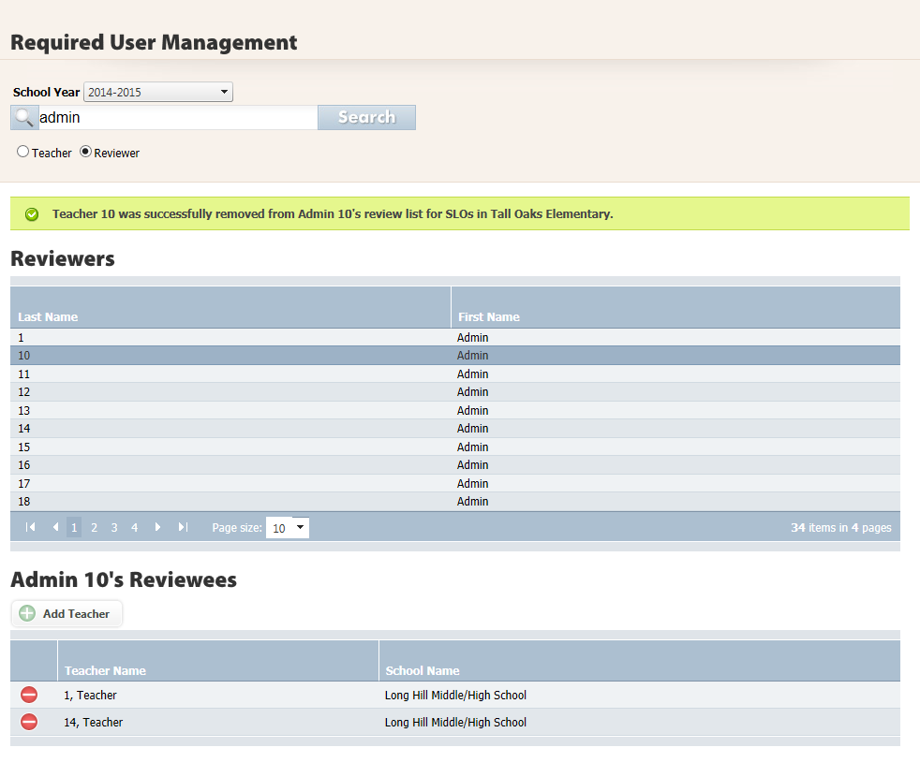

If another reviewer needs to review an SLO for a teacher that is split between buildings, the first reviewer must remove the teacher from their reviewee list. The second reviewer can assign themselves as the new reviewer to this teacher by following the steps for adding a teacher.

