Bulk Loading the SLO Required User List

This feature allows you to bulk upload a list of the SLO Required Users and their Reviewers through an Excel file.
You can navigate to this option by clicking on the APPR>SLOs>SLO Exam Management menu.
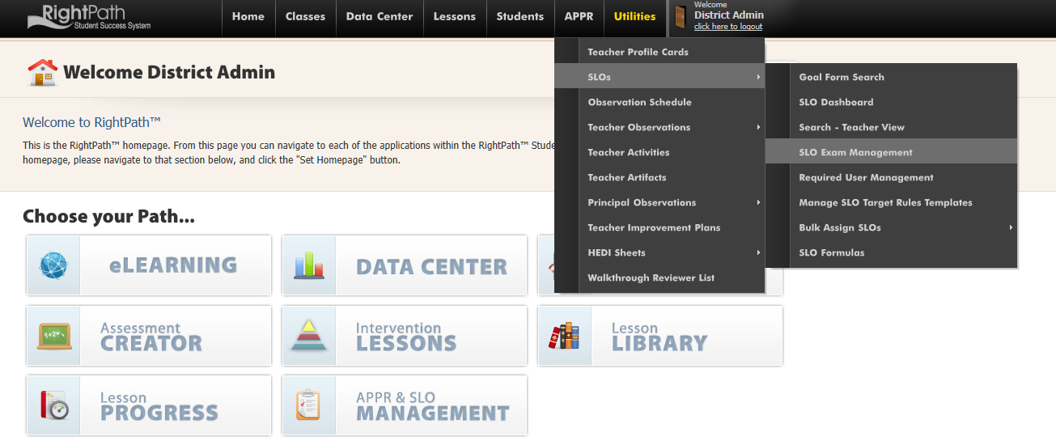

- Select the ‘Load Exams or Users’ button.
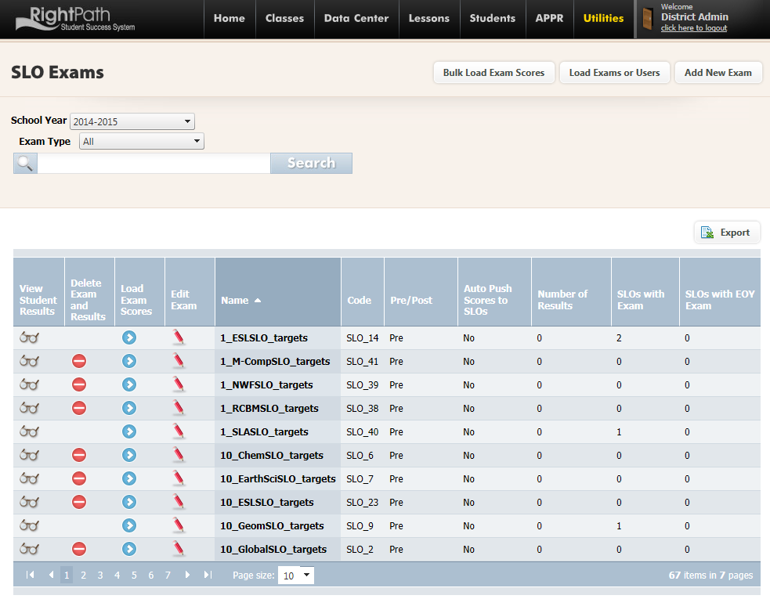
- Click the ‘Required User Loader’ radio button.

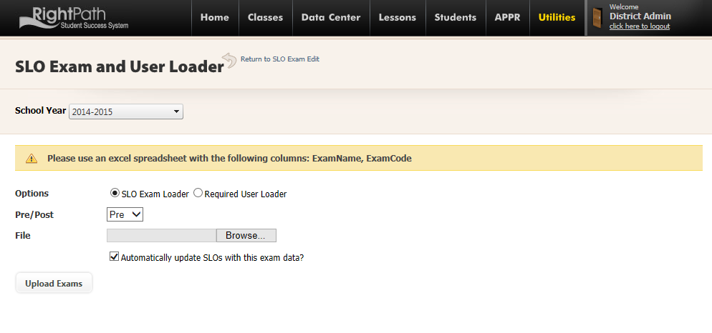
- Select the SLO Type by clicking on the ‘State’ or ‘Local’ radio button.

- Browse for your file. It must be an Excel file that contains 3 columns. The columns must be labeled TeacherID, ReviewerID, and SchoolID.

- Click the ‘Upload List’ button.

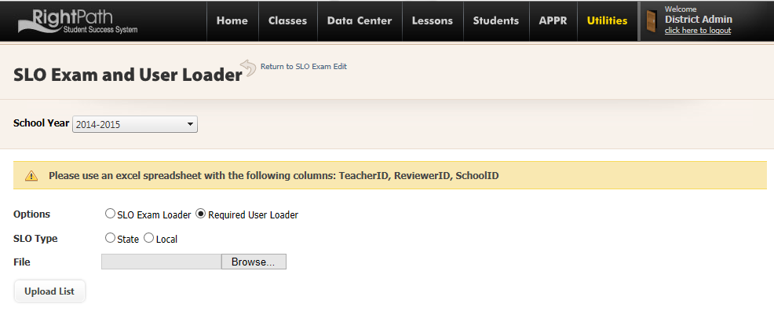

An alert will notify you that the required users have been successfully loaded.

