Bulk Load SLO Scores User Guide

The SLO Exam Management User Guide will walk you through the steps needed to load your SLO pre or post scores for multiple exams at once. You can access this permission based option under the APPR dropdown menu by navigating to APPR > SLOs > SLO Exam Management.

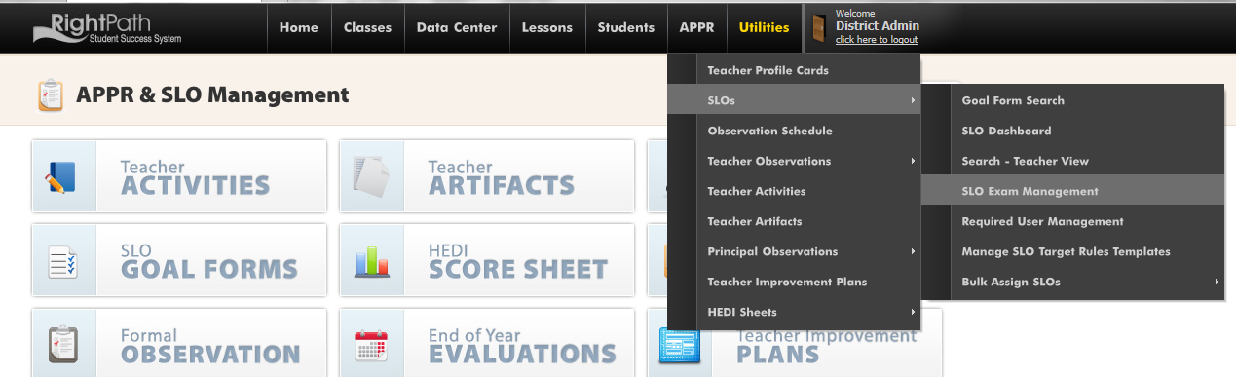

Assuming you have added your exam names previously, you will follow these steps to load your scores for multiple exams in one run.

- Click the ‘Bulk Load Exam Scores’ button at the top of the page.
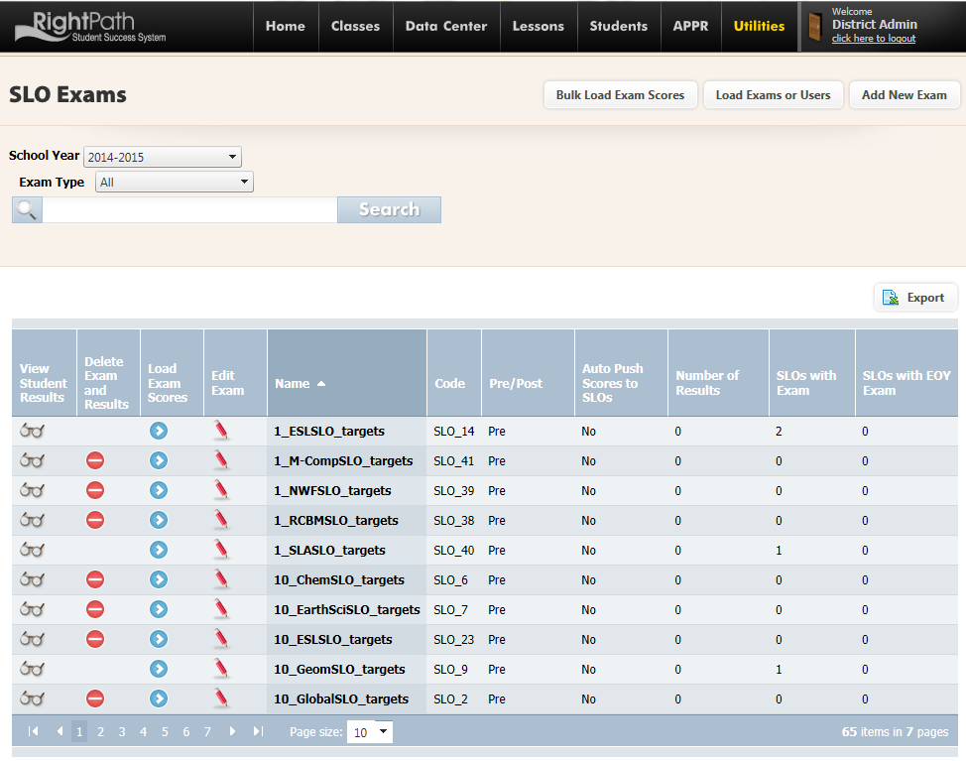
You will need to supply a CSV file that contains three columns. The data needed will be the Local Student ID#, the Score and the Exam ID#. The column headers must be LocalStudentID, Score and ExamID if you choose to use headers.
- Select the correct year from the drop down menu.
- Click the radio button choice of which Exam ID# you will match.
- Check off the box if you are using headers.
- Click on the ‘Select files’ Button and choose your file to load.
- Click the ‘Upload’ button.
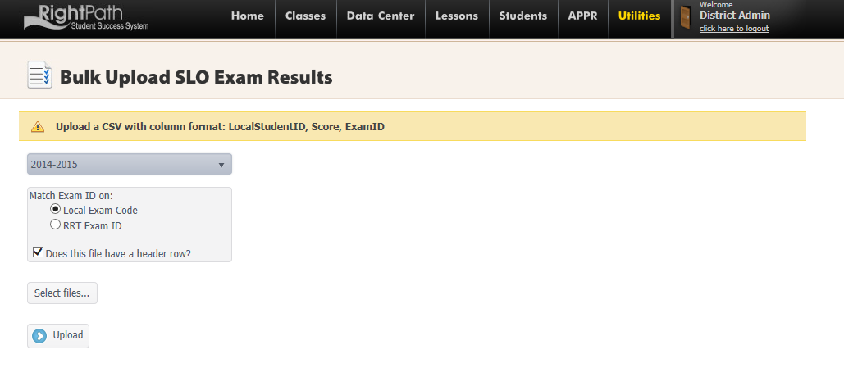
You will be directed to the Bulk Upload SLO Exam Results Mapping page. This page has 2 sections, ‘Exams Included in Upload with NO Existing Results’ and ‘Exams Included in Upload WITH Existing Results.’
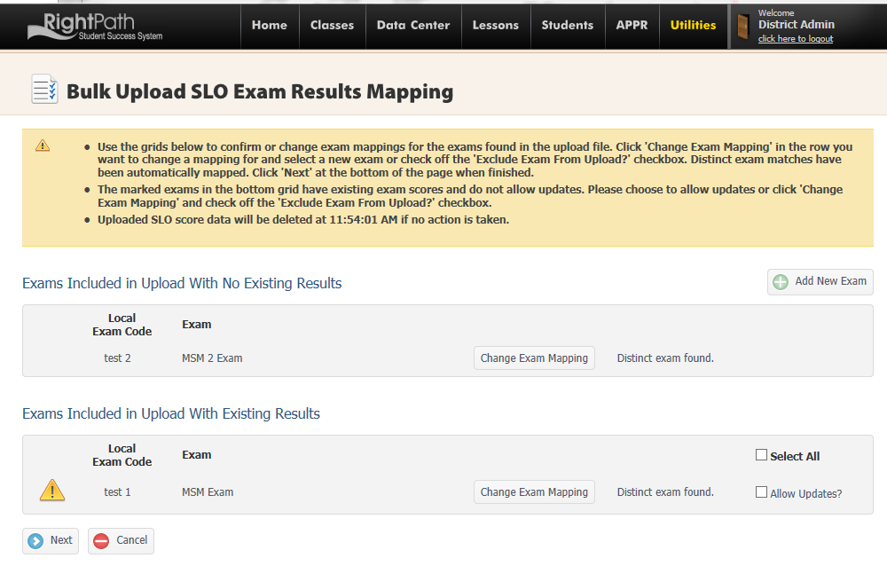
The first section, titled ‘Exams Included in Upload with NO Existing Results’ means the exam listed doesn’t have any scores loaded into the system yet. Once scores have been loaded for this exam any other time this page is opened, this exam name will show up in the second section.

The second section, titled ‘‘Exams Included in Upload WITH Existing Results’ lists exams that have had scores previously loaded. The exam may show up in this section if you have already loaded the scores for this exam and then have to run this feature again to enter makeup exam scores.

You will have the option to allow to override a previously entered score by clicking a check mark in the ‘Allow Updates?’ box. Checking the Allow Updates box will replace the score for any student listed in your current CSV file that already has a score in the system, with the new score.

On this page, you will have options available to “Change Exam Mapping”, or if the exam wasn’t previously loaded, ‘Add New Exam’. The Change Exam Mapping will allow you to select a different exam or exclude this exam from processing.
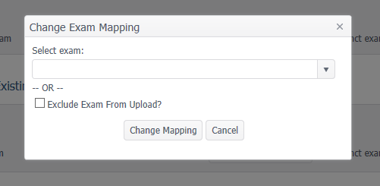

In the example below, this is the first time I am loading Exam “MSM 2 Exam” (Local Exam Code = test 2) and I have previously loaded “MSM Exam (Local Exam Code = test 1).

I want to load scores for test 1 and test 2. For test 1, if I want to overwrite any scores that are currently on the SLO I would check off ‘Allow Updates’. This will overwrite any scores that were already loaded.
- Click Next.

A display will alert you that the valid data was successfully processed. Statistics are available at a glance to see how many scores were processed for each exam and how many errors were encountered. Your data will be kept live for 15 minutes before it times out.

There are options to view the SLO Status Report, Export Errors and Finish.

Clicking on the ‘SLO Status Report’ button will allow you to open or save a report that lists which teachers and SLOs were updated from this run.

Clicking on the ‘Export Errors’ button will generate a report for you to view why a score was not processed. Reasons may include duplicate student ID#, invalid student ID# or missing scores.

- Click ‘Finish’.

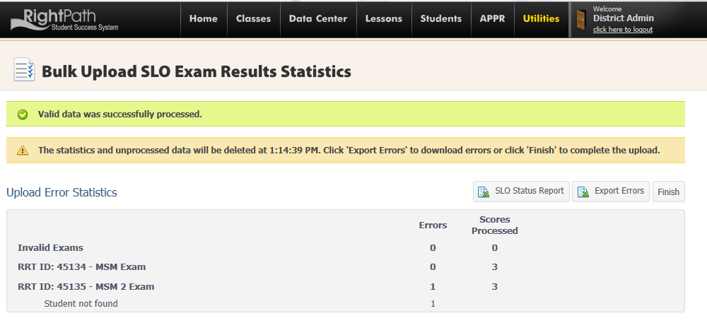
This will give you the option to complete the procedure by clicking ‘OK’ or go back and view the reports by clicking on the ‘Cancel’ button.
- Click OK.

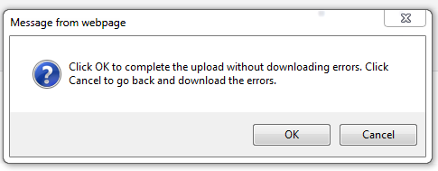

A message will display ‘Upload Complete’ and return you to the Bulk Upload SLO Exam Results page.
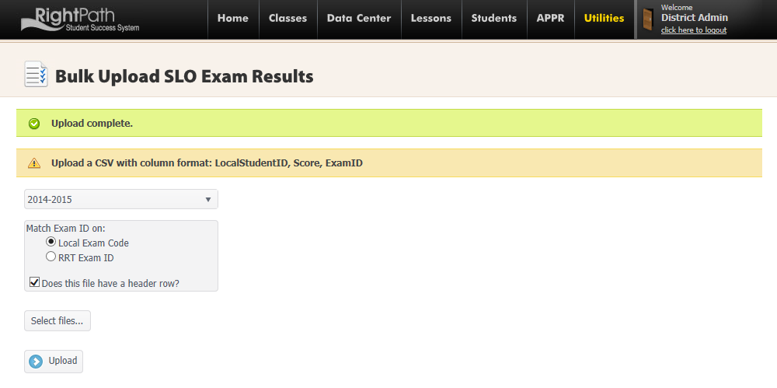

The scores have been successfully loaded for multiple exams.

