2015 Creating HEDI Sheets Using ‘Initialize’ User Guide

Create the HEDI Sheet
A HEDI sheet will need to be created for each teacher that is required to be included in the State Report. All SLOs and EOY Evaluations should be marked complete before the HEDI sheet is created. The HEDI sheets can be created one by one or in Bulk (with the option of in bulk per building) using the ‘Initialize’ button.
Navigate to the HEDI Sheet Search page by clicking on APPR>HEDI Sheets>HEDI Sheet Search.
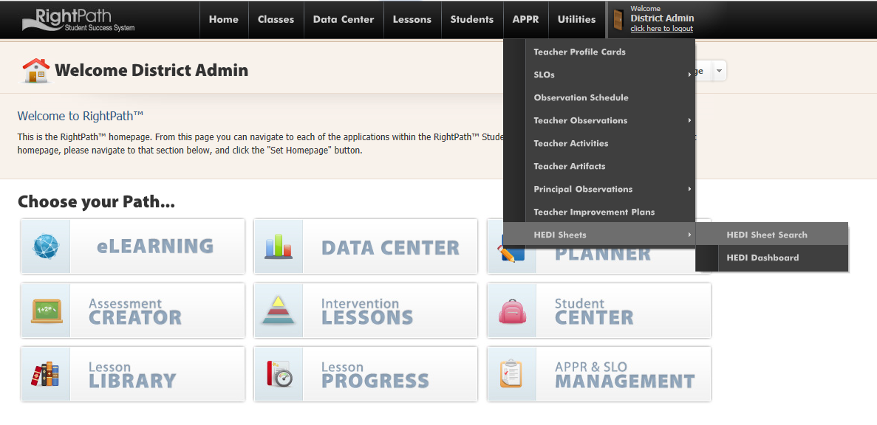
You will be directed to the HEDI Sheet Search page. If you are using the ‘Initialize’ button to create the HEDI Sheets in bulk, please read this section before you press the button. The initialize cannot be undone. The process to create one HEDI sheet at a time will follow this section.
Before you initialize, you want to be sure that all the Teacher’s SLOs (both state and local) are complete. The Teacher’s EOY Observations also need to be marked complete. When the initialize button is pressed, it will create the HEDI sheets for all active teachers in the system and populate all the completed SLO and EOY evaluation scores to the HEDI sheet. If SLOs or evaluations are not completed, the HEDI sheet will be created, but the scores will not populate and will have to be individually refreshed. Remember, the initialize cannot be undone.

Creating HEDI Sheets in Bulk Using the Initialize button
The first step in starting the HEDI Sheets in Bulk is to click the ‘Initialize’ button. The HEDI Sheets can be initialized by building or all at once. You will be redirected to the HEDI Sheet Initialization screen.

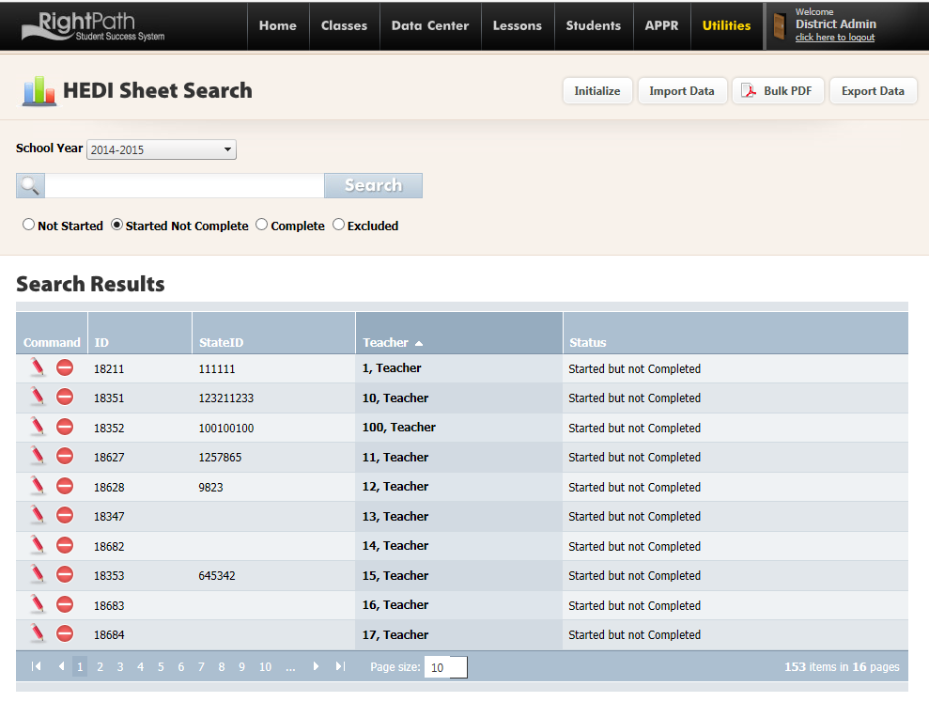
You have the option of initializing one building at a time or all buildings at once. Make your selection from the drop down menu and click the ‘Initialize HEDI Sheets’ button.

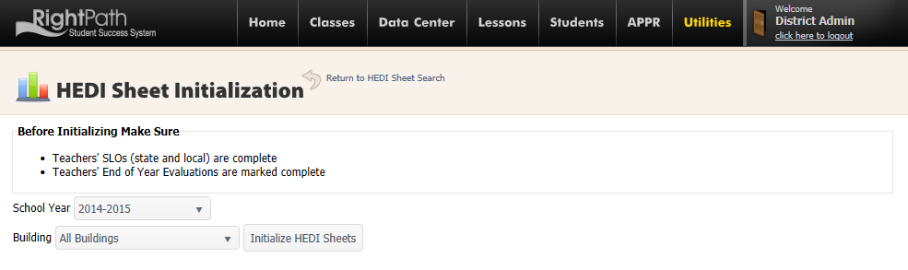
You will see a green alert to let you know the status of the HEDI sheets. Click the ‘View HEDI Sheets’ link to go back to the HEDI Sheet Search page. All the created HEDI sheets will be available in the ‘Started Not Completed’ search.
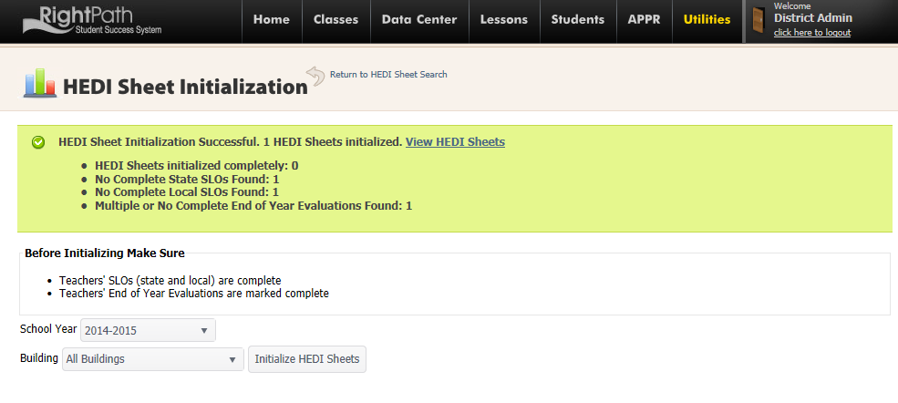
Creating HEDI Sheets Individually
To create a HEDI Sheet for one teacher, you will search for the teacher on the HEDI Sheet Search page and select the ‘Not Started’ radio button.
If the search box is left blank and the ‘Not Started’ radio button is selected, you will see a list of all the teachers who do not have a HEDI Sheet created yet.
Click on the green circle with the plus sign to create a HEDI sheet for the teacher. (You can click on the red circle with the white minus sign to exclude a teacher from having a HEDI Sheet.)
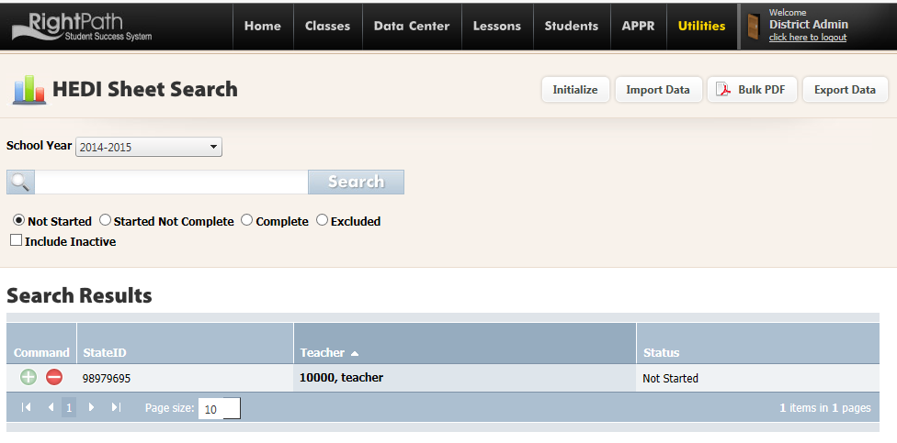
Populating Scores, Saving and Closing the HEDI Sheet
Once, you have created the HEDI sheet (either in Bulk or individually), you can search for the teacher, update scores and complete their HEDI Sheet.
Search for the teacher’s HEDI sheet that you want to work on and select the ‘Started Not Complete’ radio button. Click on the pencil to edit the HEDI sheet.

If you see a blue circle ‘i’ icon, click on it for more information that is needed to calculate the score.
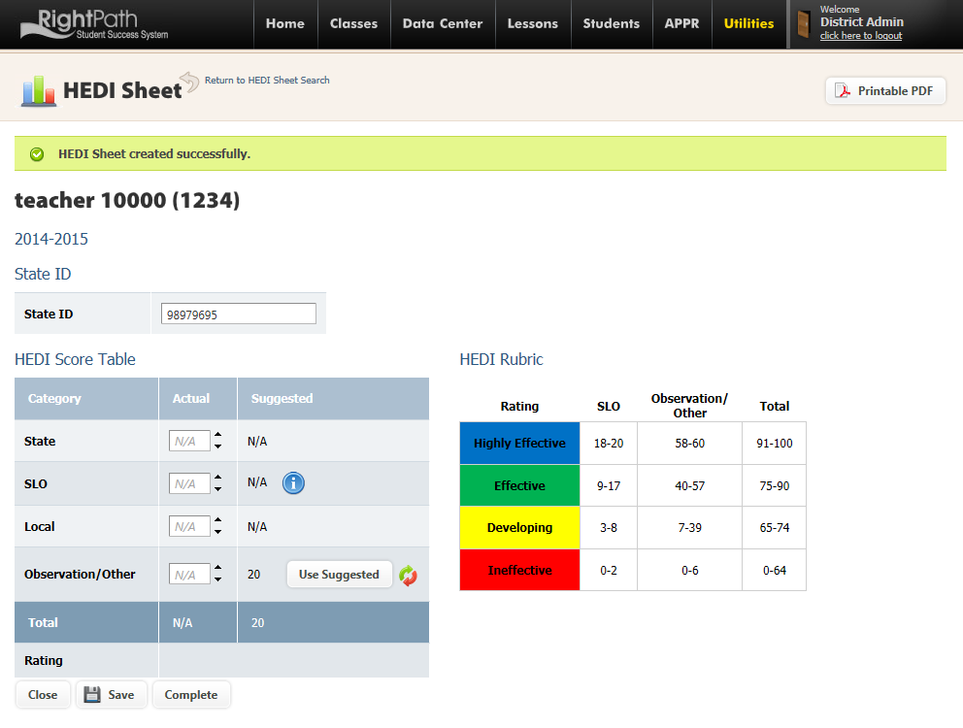

If you see the icon in line with the SLO score, click this it and select the SLOs you want to include in the SLO calculation by checking off the box preceding each SLO ID# and click the ‘calculate’ button.
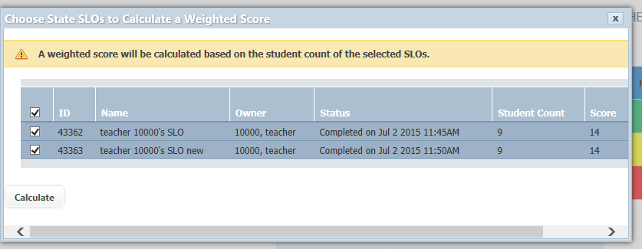

Click ‘OK’ to use the selected SLOs and return to the HEDI Sheet.
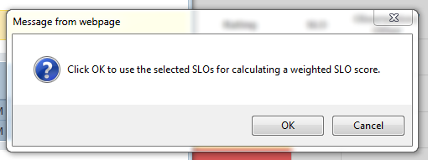
The SLO suggested score has been calculated and will populate to the ‘Actual’ SLO score by clicking on the ‘Use Suggested’ button.

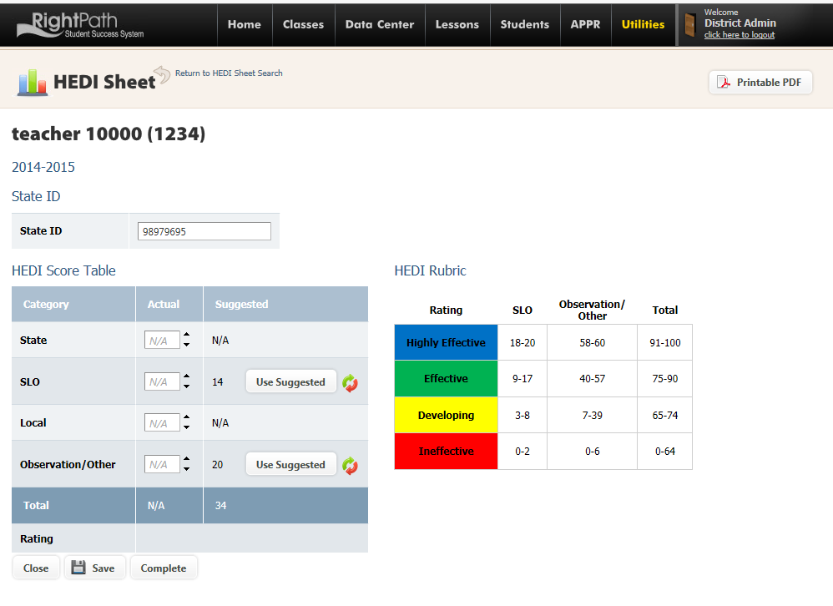

If you need to change the SLOs that you originally selected, click the red and green circular arrows to pick other SLOs and calculate again. You can also override the score by entering the score directly into the text box in the ‘Actual’ column.
The same process is used for the Observation scores to populate to the ‘Actual’ column.
Click red and green arrows to refresh the score if any changes have been made to the Evaluations or SLOs since the HEDI sheet was created to view the most up to date score.
Once all scores are visible in the ‘Actual’ column, click on the ‘Save’ button. Next, click on the ‘Complete’ button.

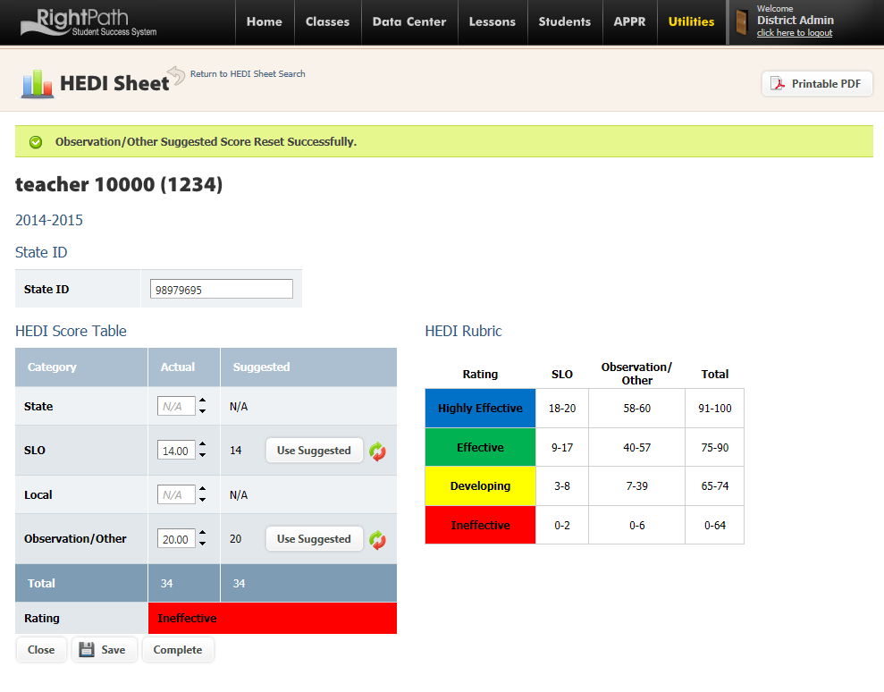
Click ‘OK’ to confirm to mark the HEDI sheet complete.
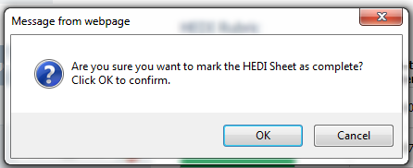
Click ‘Close’ to exit the HEDI Sheet.

