eLearning™ Dashboard (Teacher View)
The eLearning Dashboard provides a quick view of assignments, a list of recent mail messages, a view of upcoming calendar events, and a read-only view of the internal locker. This is the start page; from here, access to classes and sections are one click away.
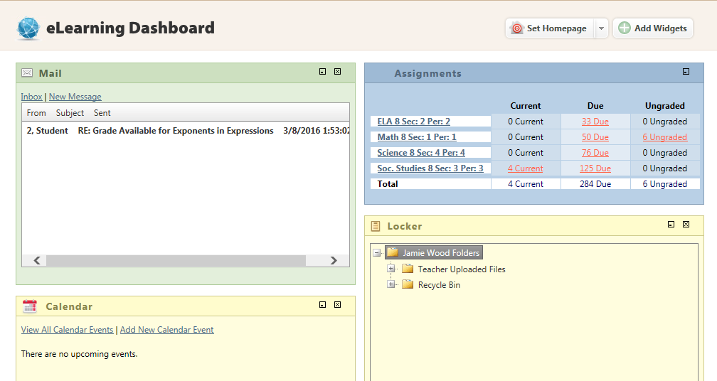

Customizing the Dashboard
All of the elements on the homepage can be customized. The widgets can be moved, reordered, collapsed, expanded, or closed. Any changes made to the homepage widgets will be saved for the next time logging into the system. This can be done by clicking the ‘Add widgets’ button.

Dashboard Calendar
The Calendar shows the most recent upcoming events. The user can add items by clicking the ‘Add New Calendar Event’ link and fill in the appropriate information. The ‘View All Calendar Events’ link will allow the user to navigate to the Calendar View page. Items in the calendar will also display a tool tip, if the mouse is hovered over the magnifying glass icon or the text of the event.

Assignments Widget
Assignments in eLearning are essentially lessons taken from a curriculum or the library that have been sent to the student to be completed and submitted back to the teacher for review.

How to view New, Due, and Ungraded Assignments
- The assignments widget on the homepage will show an at-a-glance view of all current, due and ungraded assignments. New assignments are lessons students have not opened or started. Due assignments are lessons that students have begun. Ungraded assignments are lessons that students have submitted for review.

- Clicking on any of the class names will take the user to the Classroom Homepage.

- Clicking on any of the items in the columns will provide a drop down list of the assignments.

Class Homepage (Teacher View)
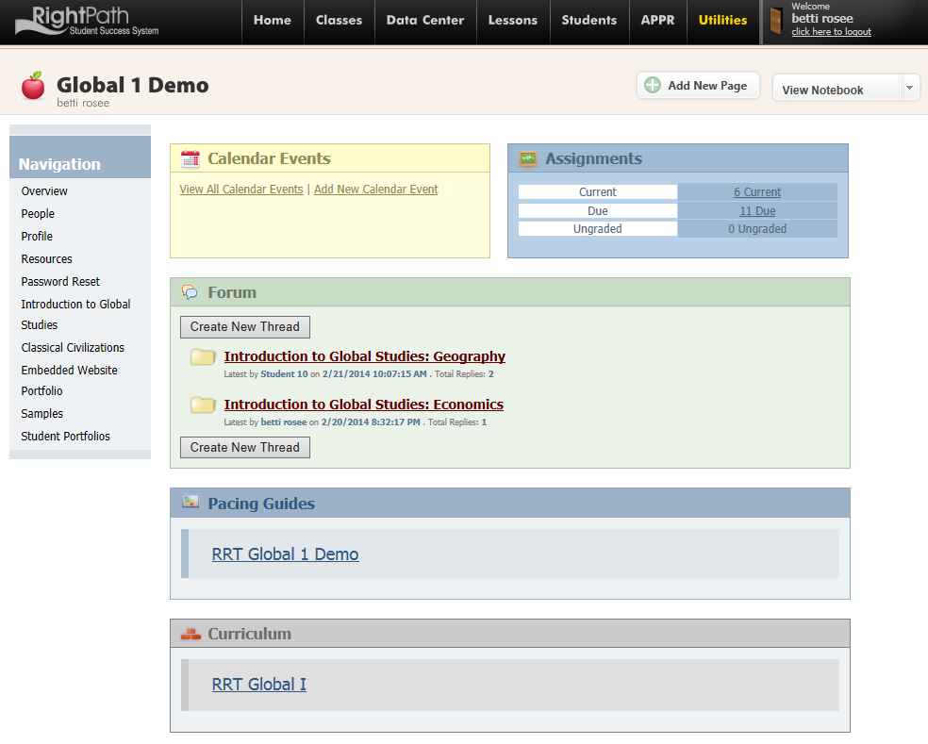
Each class within the system has its own page where all the information pertaining to that class is kept. These pages can be launched by clicking on the class name under the Classes menu in the top navigation.

The main components of the Classroom Homepage are:

- Overview
- People
- Profile
- Resources
- Password Resets
- Custom Pages
- View Student Notebooks
Navigation
Overview Page
Class Calendar: Use the Add New Calendar Event to add items to the calendar. Click the View All Calendar Events to see the month view calendar.
Assignments Widget: This widget functions the same as the eLearning Dashboard except it will display only the class assignments
Forum: To promote class discussion, use the Forum Discussion. Click Create New Thread button
Pacing Guides: If a Pacing Guide is attached to the class, click on the name of the Pacing Guide to view it.
Curriculum: If a curriculum is attached to the class, click on the name of the curriculum to view it.

People Page
This tab contains a list of all the students currently enrolled in the class as well as the helpers for the class. From this view, teachers can send mail to students and helpers, generate Rosters with student usernames and modify which helpers are associated with the class.
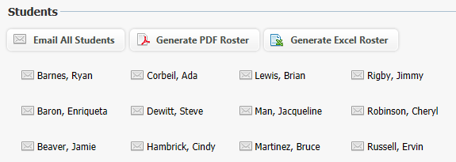
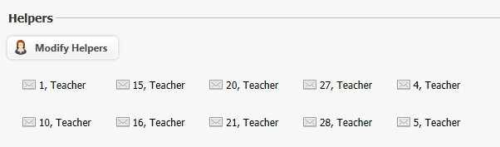
Profile Page
This section contains the profiles for both the teacher and class. A teacher profile consists of a teacher photo and a description about the teacher. The class profile contains a text description about the class.
Resources Page
This tab contains these four resources for a class: “Class Resources,” “Online Textbooks,” “Your Bookmarks,” and “Classroom Files.”
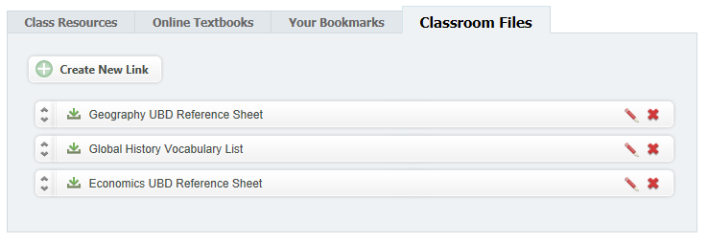

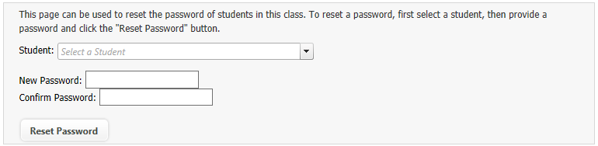
Password Reset Page
This page can be used to reset the password of students in this class. To reset a password, the user should select a student, provide a password, and click the ‘Reset Password’ button.

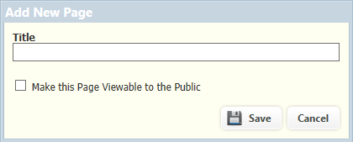
Adding a Custom Class Page
Any teacher can add custom pages to their classroom homepage. On the top of the page, click the Add New Page button. Then create a Title for the page and choose if you want this page to be viewable to the Public.
Using the textbox, resources, notes and media can be put in. Multiple pages can be added to the class page to organize resources for students into Units or Topics. Many teachers find this resource to be beneficial to beginning a flipped classroom.

Once the page is completed, click View this Page to preview the page or click Save when it is completed.
Searching for a Curriculum
- From the Lessons menu on the top of the screen, the user can click the Curriculum Search link.
1
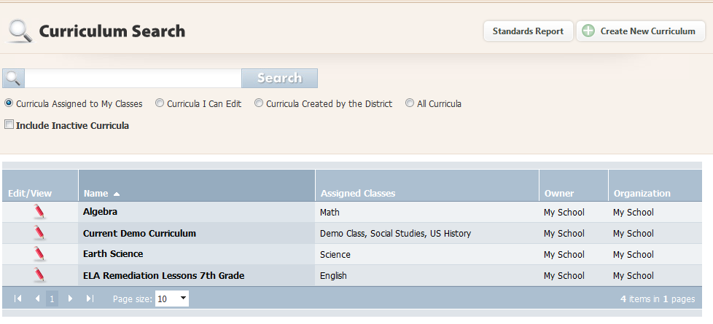
4
3
2
- The user can specify the curricula to be searched by choosing from the options. Entering the search text will allow the user to find a specific curriculum. This text will be matched against the curriculum names and lessons within the curriculum. The following options are available:
  - Curricula Assigned to My Classes – Only curricula assigned to specific teachers.
  - Curricula I Can Edit – Only curricula with access to edit (i.e. curricula owned by a specific teacher, a group with specific members, or owned by the district) are shown.
  - Curricula Created by the District – Only curricula owned by the school district are shown.
  - All Curricula – All curricula, including those obtained from Right Reason Technologies, are shown.
  - Include Inactive Curricula – Includes curricula currently set as inactive in the search.
- Click the ‘Search Curriculum’ button to retrieve the results.
- Use the Edit/View icon to open the curriculum to view.

Creating Assignments
RightPath™ allows two different ways to create an assignment: assigning from lesson progress or assigning from a curriculum.
Assigning from Lesson Progress
Lesson Progress is found under the Students tab in the top navigation. This method will be used to assign an individual student a lesson from a curriculum to which he or she is assigned. The user should perform these steps to assign from lesson progress:
- Choose the Student by either typing the student’s name into the textbox or selecting a student from the drop down menu.
- Choose the Class from the class dropdown menu. The color coding can be used to determine if the student needs more work.
- You can utilize the filters to determine what you see in the student’s lesson progress.
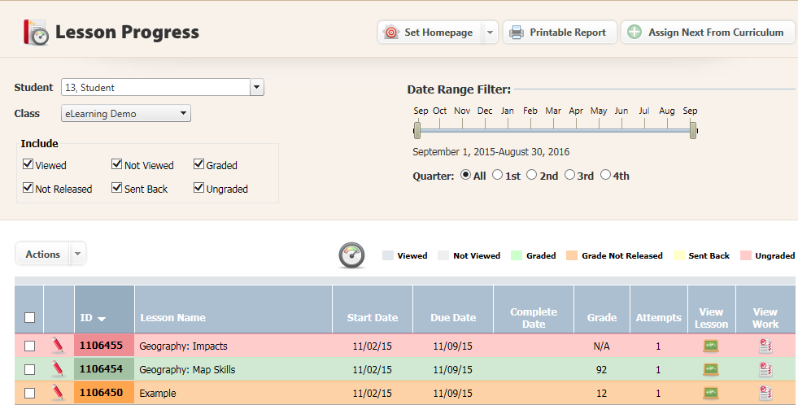
- Click the ‘Assign Next from Curriculum’ link.
1
2
3
4

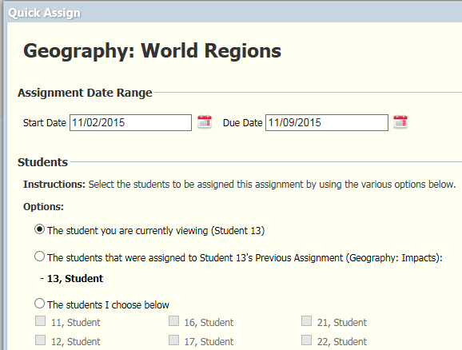
A pop-up window with options will appear:

  - Select the start and due dates.
  - Choose to assign only the student you’re currently viewing, students that were assigned the previous assignment, or select students from the class.
  - Click Assign. Close the confirmation box to return to the student’s lesson progress.

Assigning from Curriculum
Accessing a particular curriculum can be done through the Curriculum Search page. The Curriculum Search can be found under the Lessons menu.
The user should:
- Using curriculum search, search for the desired curriculum and choose the unit which holds the lesson or lessons to be assigned.
- Click the checkbox next to the lesson(s) or unit(s) to be assigned.
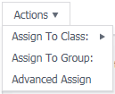
- Click the ‘Actions’ button at the top of the units. This will open a drop down menu with 3 options: Assign to Class, Assign to Group, and Advanced Assign.
- Clicking on ‘Assign to Class’ will open up a side menu of any classes attached to your account. By selecting a class, it will assign the lesson(s) to all of the students associated with that particular class.
- If you have created a specialized group, you can utilize the Assign to Group option to assign the lesson or lessons to everyone within that group.
- To assign to multiple classes or a particular group of students within a class, click ‘Advanced Assign’ which will bring you to the Assignment Details page.
  - In this page, there are many options to customize the assigning of the lesson. Options include selecting the date(s) of the lesson(s), choosing to only include certain components of the lesson(s), and selecting the Class and/or Students to be assigned.

  - To select an entire class, click the checkbox next to that class. For specific students, click the dropdown arrow next to the class that those students are in which will open up the roster of students. This will allow you to select the boxes of particular students.

- Once you have selected the components you’d like to include and student or group of students, click Create Assignment.

Auto-Assigning ILPs
The RightPath™ Student Success System is equipped with a way to automatically assign students individual learning plans based on an assessment within the system. This user guide will show you how to utilize the auto-assign feature once the student has submitted his or her assessment.
The Auto Assign Lessons feature can be found under the Lessons tab.
- Choose the Class in the class dropdown.
- You can choose to assign All Students or choose a specific student in the class to assign.
- Choose the Exam Type. If you are assigning from a Benchmark exam taken in the RightPath™ system, you will choose Benchmark Exam. All others will choose Assessment Creator.
- Choose the specific exam you were to auto-assign from. Some classes give a variety of assessments to their students that they can receive individual learning plans from, choose the correct exam in the exam dropdown.
- In the Assign From section, you will choose whether the student should be assigned from RTI Lessons (usually utilized with ELA and Math 6-8) or from the classes curriculum. In most cases you will choose Class’s Curriculum.
Note: the correct curriculum must be attached to the class in order to assign from curriculum.
- Choose a start date which will be the date the exam is first available to the student.
- Choose an end date. The end date will not make the lessons disappear once the date is reached, it will simply move the lessons from the due column, to the late column to let the student know he/she should have completed them by this date.
- Click assign. Once you’ve assigned you will be given a total number of assignments the student was given according to his or her individual learning plan.
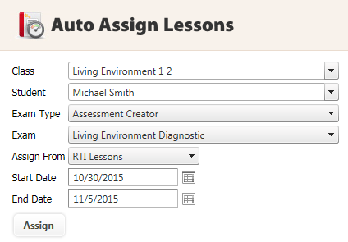

Lesson Progress
In the RightPath™ Student Success System, there are three different ways to view and grade assignments. These three ways are through the Student Work, Gradebook, and Lesson Progress features in the system.
Lesson Progress Overview
The Lesson Progress page can be found under the Students tab.
- Type the student’s name and then choose the class to be viewed.
- This will populate a color-coded list of assignments the student has had assigned for this class.
- The Key above the list will show the meaning of the colors.
- To view the student’s work, click on the ‘View Work’ icon. This will bring up a report of the student’s answers. If the assignment has been auto-graded, the correct answers and whether or not the student answered correctly or incorrectly will be displayed. If the question is an essay, the student’s answer will also be displayed for review and grading.
- Click the name of the assignment to expand it to see details like grade, feedback, results etc. This is where the student’s grade is entered. Note: Anything may be typed into the grade box; however, grades entered out of 100 points will be automatically averaged in the Gradebook.
- Actions Button: This new feature allows the user to lock, release grades, reassign, or unassign one or multiple lessons by checking the check box next to the lesson name and choosing the action you’d like to occur.
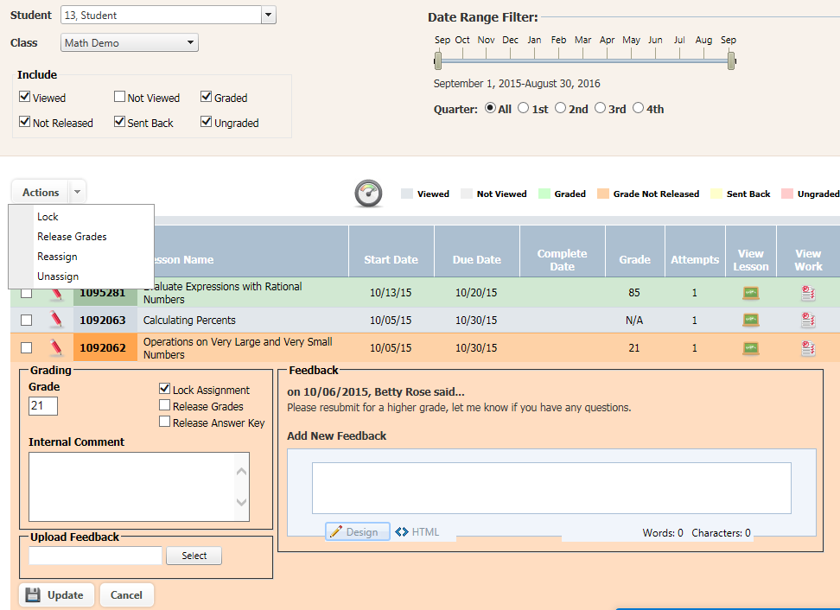
- When finished editing, click ‘Update’. This will save and send the feedback and/or grade.
2
1
6
3
4
5
7

View Student Work
One of the options within the RightPath™ system for grading is through the View Student Work feature. You can access this feature through the Lesson Progress page or through Gradebook. Choose the lesson you’d like to grade and click the View Work icon that looks like a graded paper. This will open the student work for that assignment.
- You can choose the components of the lesson you’d like to view. Select
  - View Ungraded Content to see any extended response questions that have not yet been graded. This will hide all autograded questions and learning components, as well as questions you’ve already graded.
  - View Gradable Content will show you all question types and allow you to edit even the autograded questions. Check the Hide Autograded Questions checkbox if you wish to hide autograded questions.
  - View All Content will display all learning compoennts and questions.
- The Preview button will allow you to access the answer key and print handout for the lesson.
- Attempts: This dropdown shows you how many times the student has taken the assignment. You can view the student work from each of the attemps by using this drop down.
- Grading:
  - Autograded questions will be graded as the student answers the questions. These questions are either correct or incorrect and usually worth 1 point so partial credit cannot be given.
  - Extended Response: when grading an essay, the teacher can choose correct, incorrect, or partial credit if the question is worth more than one point. The teacher can enter the partial credit crade in the partial credit checkbox.
  - Click the Update Grade button once you’ve finished grading the assignment. This will save all of your changes and update the final grade.
1
2
3
4
5

Giving Feedback
Each time a student’s work is graded, feedback may be sent when releasing the grade to let the student know how he or she did and to leave any specific comments. The teacher also has the ability to leave Internal comments that only graders can see. View the different components of Feedback and Comments below.
- Expand the lesson by clicking on the title. Once the lesson is reviewed and grade determined, find the Feedback section in the expanded lesson. This is where you can write feedback to the student. Simply write your message to the student in the box and click the Update button to send it. This will send the student an email to his account with the message you typed.
- Uploading a feedback document: to upload a document, find the upload feedback section, browse your computer for the file you’d like to upload and attach it. Click update once you’re finished to send the document to the student email within their account.
- Adding an Internal Comment: this feature is designed so that you can leave yourself or other teachers that may be grading work a mess without the student seeing it. In order to do this, type your message in the Internal Comment box and click update. This message will remain here for yourself and others to view.
1
2
3

Sending Work Back
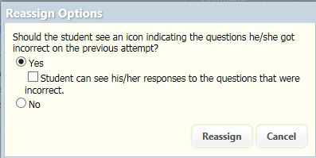
When a student does poorly on an assignment, there is an option to send the assignment back to the student to try the lesson again. The user should:
- Check the boxes next to the lessons you’d like to reassign.
- Go to the actions button and choose Reassign. Then you will receive a pop up.
- You can choose to let the student see what he or she got wrong, see his or re responses, or give the student a blank assignment. Choose appropriately and then click Reassign.

Gradebook
The Gradebook feature in RightPath™ is another way users can view and grade student and classroom work. This userguide will explain the components of gradebook and guide the user through the steps on how to view and grade student work.
Gradebook Overview
- Curriculum Integration: The Gradebook integrates directly with the curriculum for a class. If the selected class has an attached curriculum, all lessons in that curriculum will be shown in the Gradebook in the order that they appear in the curriculum. Lessons assigned that fall outside of the curriculum are also shown at the end. Curriculum lessons are colored blue, and non-curriculum lessons are colored gray.
- Lesson Progress Integration: Clicking a student’s name will navigate directly to that student’s Lesson Progress page with the class and date range already selected, based on the class and date selected from the Gradebook.
- Color Coded Grades: Lessons are color coded so that teachers are able to see, at a glance, which lessons have been graded, ungraded, assigned, and unassigned.
- Letter Grade/Multi Grade Support:
- Grades with multiple numeric grades are automatically averaged and receive an 'Avg' label. The class average is shown for each lesson in the Average Grade column.
- Single letter grades are marked with an alpha symbol and the letter grade is shown.
- Multiple letter grades are marked with an alpha symbol and the word 'Multi' is shown.
- Export to Excel: The Gradebook can be exported to an Excel® spreadsheet that will contain the gradebook as it was seen in the RightPath™ including all labels and color-coding.
- Freeze student Column: is a feature that keeps the student column visible as you scroll through the lessons assigned to each student.
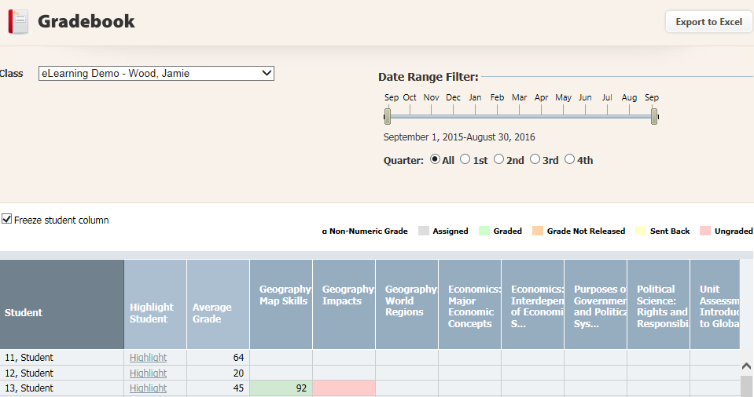
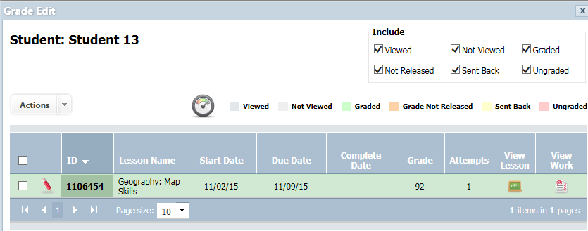
- Grade Edit: when you click on a lesson to view or grade you will see the grade edit pop up, this will be explained in detail in the next section; Gradebook: viewing, grading, sending work back.
6
2
1
5
4
3
7

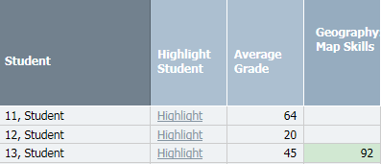
Gradebook: Grading, Feedback, Reassigning
When you’re ready to view or grade a lesson, find the correct row of the student you’d like to view and the column that the lesson is in and click. This will pop up the Grade Edit function.
- To view the lesson, click the chalkboard icon.
- To view the student’s work, click the View Work icon. This will allow you to see the student’s answers to each question.
- Grade: to enter a grade for the lesson, click in the grade box and type the grade. Note: this box will only be available if the student has submitted the assignment, if not you’ll receive a message that requires you to enable grading.
- When you grade you can choose to release the grade, lock the assignment from student’s view, or release the answer key by checking the checkbox next to the appropriate action and clicking the update button.
- Once the lesson is reviewed and grade determined, find the Feedback section. This is where you can write feedback to the student. Simply write your message to the student in the box and click the Update button to send it. This will send the student an email to his account with the message you typed.
- Adding an Internal Comment: this feature is designed so that you can leave yourself or other teachers that may be grading work a mess without the student seeing it. In order to do this, type your message in the Internal Comment box and click update. This message will remain here for yourself and others to view.
- Uploading a feedback document: to upload a document, find the upload feedback section, browse your computer for the file you’d like to upload and attach it. Click update once you’re finished to send the document to the student email within their account.
- Actions Button: This new feature allows the user to lock, release grades, reassign, or unassign one or multiple lessons by checking the check box next to the lesson name(s) and choosing the action you’d like to occur.
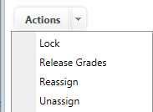
3
2
1
5
6
7
4
8

System Reports
There are many student reports that can be run and accessed through the “Students” menu in the top navigation when you sign in to RightPath™

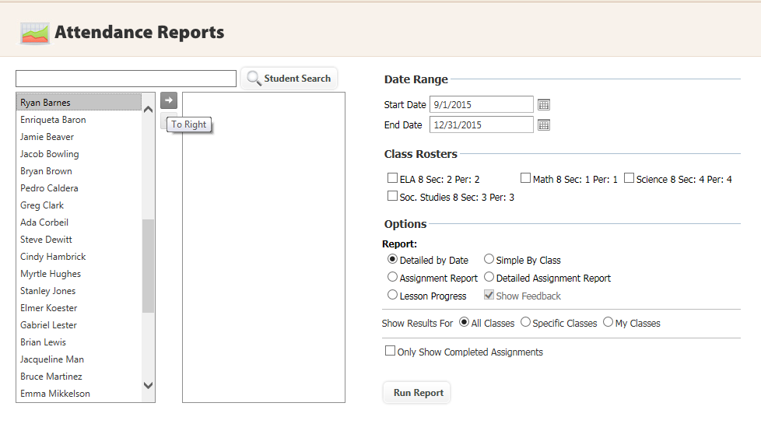

To run a report, the user should:
- Populate the report by selecting a Class Roster, a student, or group of students.
- Select the dates to run the report.
- Select the report and any of other filtering options desired.
  - Choose a report.
  - Choose to run for all classes, selected classes, or “my classes.”
  - Choose to only show assignments that have been completed or all assignments.

Report Descriptions
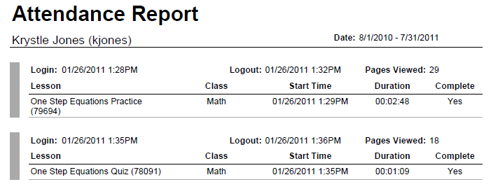
Detailed by Date
This report displays the lessons worked on during the chosen time frame. It is first broken down by student and then each login session for the RightPath™ platform. It will track each time an assignment is clicked and report how much time was spent on the lesson. This report will display all login session data and indicate if the assignment was submitted as complete.
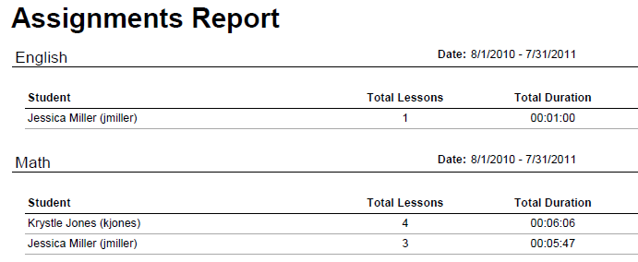
Suggested Uses: Attendance, tracking, lessons being worked on/time spent in blended classrooms, monitoring time spent on assignments at home.
  - Simple by Class
This report looks at each class selected and lists the students enrolled, how many assignments worked on or completed during the chosen time frame, and total time spent on the assignments.

Suggested Uses: Overview of a class to see how many lessons are being completed for all the selected students
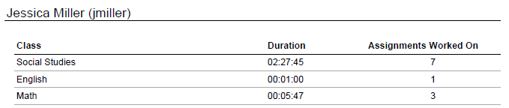
  - Assignment Report
This is a simplified report that is broken up by student and lists all the students’ classes and how many assignments were worked on or completed during the chosen time frame. It also will list how much total time was spent on the lessons.
Suggested Uses: Simple view of number of lessons worked on/completed by student during a particular time frame.
  - Detailed Assignment Report
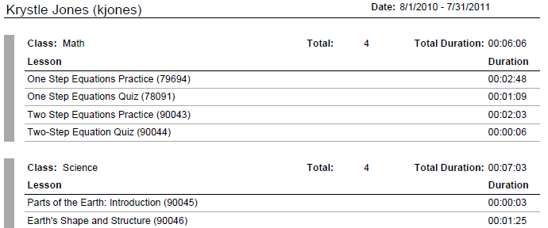
This report is similar to the regular assignments report, but it shows more information. For each class, it lists the name of each lesson worked on or completed and how much time it took to complete. For this report, each student will begin on a new page.
Suggested Uses: Provides detailed tracking of assignments worked on or completed for each selected class, including time spent on each assignment.

